***PRACTICAL: 1***

***AIM: To study and implement basic network configuration commands.***

1. ***Ping:***

***The ping command first sends an echo request packet to an address, then waits for a reply. The ping is successful only if: the echo request gets to the destination, and. the destination is able to get an echo reply back to the source within a predetermined time called a timeout.***

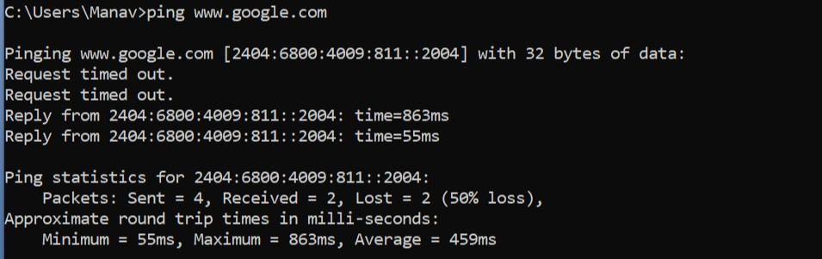

1. ***Pathping :***

***It helps you to find the location of a packet loss in a route between you and a host.  
The Pathping command is a combination of Ping and Tracert. Where a ping command only test the network connection between the source (your computer) and the destination, Pathping will test the connection to each hop between it. When you run a Pathping, it will first trace the route to the destination and then performs a ping to each node in between it.*** 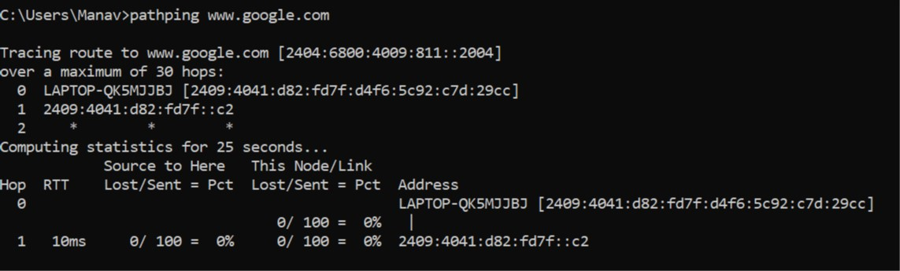

1. ***Traceroute :***

***The main difference between tracert and pathping is that tracert helps to find the actual path from the source to the destination device while pathping is a command that provides information about network latency and network loss at intermediate hops between the source and the destination devices***

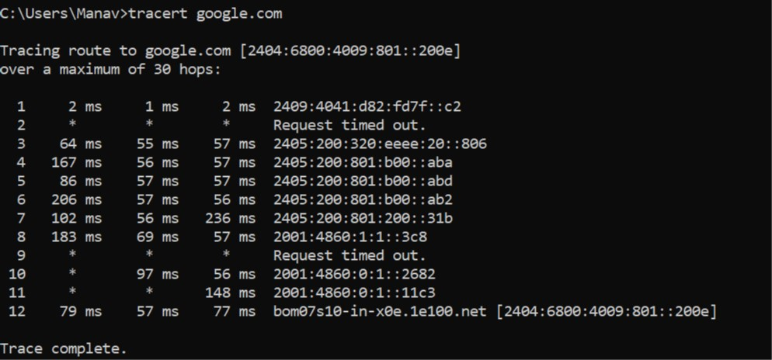

1. ***Ipconfig:***

***Displays all current TCP/IP network configuration values and refreshes Dynamic Host Configuration Protocol (DHCP) and Domain Name System (DNS) settings. Used without parameters, ipconfig displays Internet Protocol version 4 (IPv4) and IPv6 addresses, subnet mask, and default gateway for all adapters.***

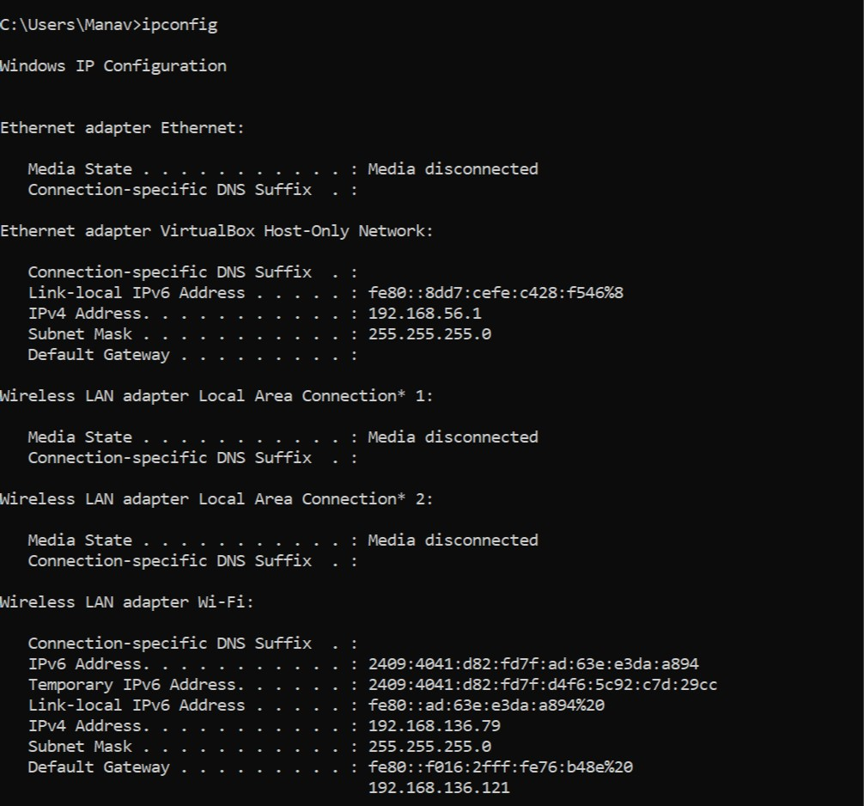

1. ***NSlookup:***

***Nslookup followed by DNS name and returns IP address and vice versa also.***

***Ex: If "WhatIs.com” is entered into a nslookup program, the user would receive the site’s IP address as a response, which happens to be 65.214.43.37. If the user enters "65.214.43.37", it would return "sites.techtarget.com".***

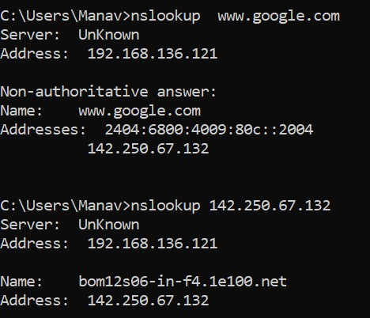

1. ***Netstat :***

***Displays active TCP connections, ports on which the computer is listening, Ethernet statistics, the IP routing table, IPv4 statistics (for the IP, ICMP, TCP, and UDP protocols), and IPv6 statistics (for the IPv6, ICMPv6, TCP over IPv6, and UDP over IPv6 protocols). Used without parameters, this command displays active TCP connections.***

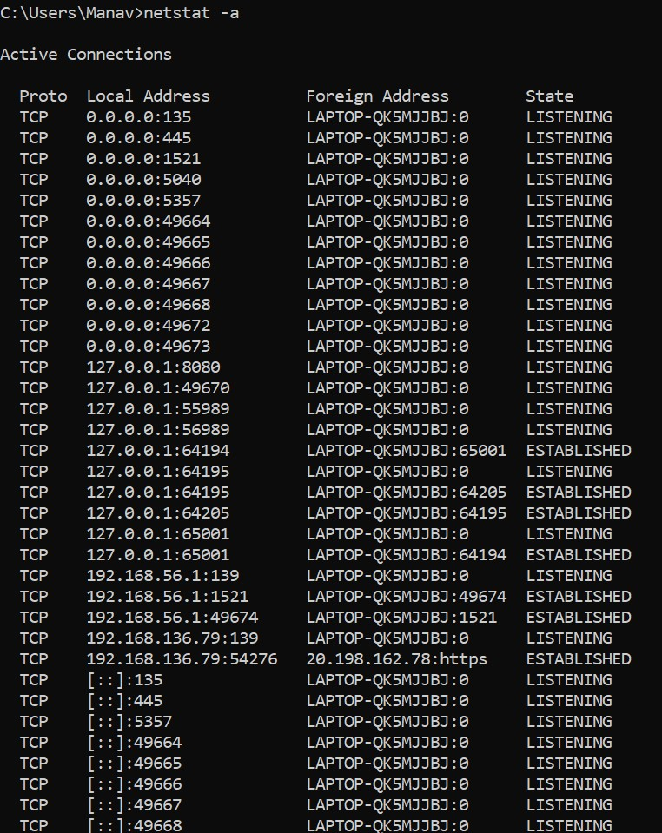

1. ***Arp :***

***The Address Resolution Protocol(ARP) is a communication protocol used to discover the data-link layer address(Layer 2 address like Media Access Control(MAC) address) associated with an Internet layer address(Layer 3 address like IPv4 address). ... As a result, ARP is said to be a link layer protocol.***

